Name of Committee: _ 1stVice President_________________
Committee Members (Present): N/A
Chair/Co-chair of Committee: ___N/A________________________________________
Date: April 15, 2015__________
Note Taker: ___N/A______________
Subject of Meeting: _Report of 1st Vice President______________________________________
Report: (include supporting materials, budgets, motions, requests, etc.)
Service Projects
Thanks to Linda Johnson and the Physical & Mental Health committee for submitting an awesome application for a chapter program award.
Risk Management
No updates.
Coffee Break Topics
Received no feedback or submissions on what was learned.
Technology
No update. Chair will report out.

Action Items/Tasks:
- Will present the Letter of Service Area to chapter during chapter meeting for vote and send recorded approval with letter to RD Turner. It also needs to be noted in e-board minutes this month.
- PP&D – still need to meet with chair and committee to finalize calendar for upcoming year and get chapter approval. This is to facilitate the compliance deadline of June 30th.
- DOTY – Committee met: Allison Campbell, Angela Freeman, and Kim Gaines. There were five submissions that met the minimum evaluation score of 23. The nominees are Karen Abron, Patricia Ann Brown, Ebony Hicks, Marie B. Johnson, and Sonya Weaver. The five ladies will be presented for chapter vote by secret ballot during April meeting.
Recommendations:
- It is recommended we vote on the Letter of Service Area to RD Cheryl Turner. Record vote outcome and forward minutes to RD by April 25, 2015.
- It is recommended that the DOTY winner have a designate seat at chapter meetings, parking lot spot, recognition at chapter events (parades, Founders Day, etc.), and a honorarium of $250 (if budget permits) to use for designated Delta functions.
Signature of Committee Chair: _Kim W. Gaines__

April 18, 2015

Soror Cheryl Turner
Southern Regional Director

Soror Regional Director Cheryl Turner,
The Augusta Alumnae Chapter, Delta Sigma Theta Sorority, Inc. requests that the chapter’s service area be redefined. The current service area (as identified in the charter) is Augusta, Georgia. To clarify, Augusta Alumnae is not requesting any name change or alteration to its charter justification or focus. However, Augusta, Richmond County and the Central Savannah River Area (CSRA) have greatly changed. Although the former has grown, the chapter has not addressed bringing its service area into the present. We have discussed defining the service area by zip code to include non consolidated communities and specify county boundaries clearly, and to expand to other surrounding counties not serviced by a Delta chapter.
With the above stated, the recommended change in service of Augusta Alumnae Chapter, Delta Sigma Theta Sorority, Inc. is the following:
Augusta-Richmond County, Fort Gordon, Georgia (has Richmond County school on its post), non-consolidated cities of Richmond County (Gracewood, Blythe, and Hephzibah), and Burke County (which is a part of Augusta, GA metropolitan area).
In particular, the zip codes include Augusta - 30901, 30903, 30904, 30905, 30906, 30907(Richmond Co. only), 30909, 30912, 30914, 30916, 30917, 30919, 30999; Gracewood- 30812 (Not consolidated); Blythe – 30805 (Not consolidated); Hephzibah – 30815 (Not consolidated). Burke County covers six cities and is southeast of Richmond County: Girard – 30426; Gough – 30841; Keysville – 30816; Midville – 30441; Sardis – 30456; Waynesboro – 30830.
To further visualize the recommended change in service area, I have enclosed a copy of the county map of Georgia, and Richmond County zip code map. The change in service area does not affect or infringe on another chapter and is consistent with the area of service we currently operate within.
Thank you for your serious consideration of the chapter’s recommendation.

Yours in Delta,

Angel Little
President, Augusta Alumnae

County Map of Georgia
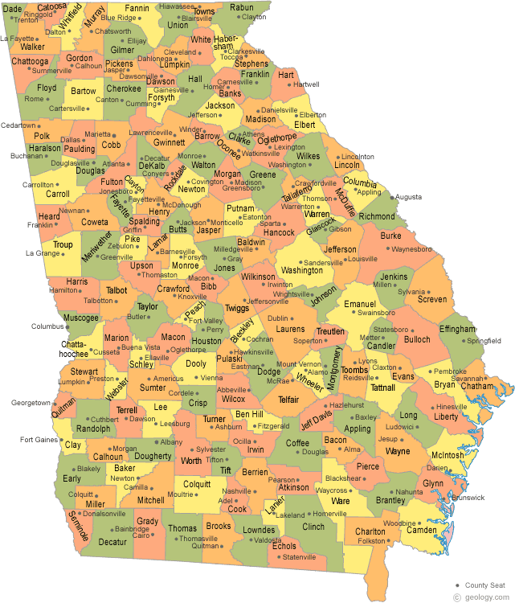

Related County Zip Codes
