Name of Committee: _ 1stVice President_________________
Committee Members (Present): N/A
Chair/Co-chair of Committee: ___N/A________________________________________
Date: May 11, 2015__________
Note Taker: ___N/A______________
Subject of Meeting: _Report of 1st Vice President______________________________________
Report: (include supporting materials, budgets, motions, requests, etc.)
Service Projects
None.
Risk Management
No updates.
Coffee Break Topics
None.
Technology
Chair will report out.
Action Items/Tasks:
- The Letter of Service Area was received by RD Turner, and forwarded to National S&S Member, Joanelle Lawson. Soror Lawson confirmed receipt of update P&P and Rules of Order Form.
- DOTY and STARS program held on April 26, 2015 was absolutely wonderful. Congratulations to 2015 DOTY Ebony Hicks. The 2014 and 2015 DOTY recipients received a bouquet of roses. Data: Delta Academy (14); Delta GEMS (24); EMBODI (6); AAC Deltas (41); General (50).
Recommendations:
- Establish a special committee for DOTY, COTY and coordination of STARS and other such activities. Recommend the committee name of Awards and Recognition Committee.
- Delta House, Inc. is going to place new name stakes for DOTY and chapter president parking spaces.
- Recommend PP&D create an evaluation form over the summer that can be used by everyone, to ensure vital data is collected in a timely and efficient manner.
Signature of Committee Chair: _Kim W. Gaines__

April 18, 2015

Soror Cheryl Turner
Southern Regional Director

Soror Regional Director Cheryl Turner,
The Augusta Alumnae Chapter, Delta Sigma Theta Sorority, Inc. requests that the chapter’s service area be redefined. The current service area (as identified in the charter) is Augusta, Georgia. To clarify, Augusta Alumnae is not requesting any name change or alteration to its charter justification or focus. However, Augusta, Richmond County and the Central Savannah River Area (CSRA) have greatly changed. Although the former has grown, the chapter has not addressed bringing its service area into the present. We have discussed defining the service area by zip code to include non consolidated communities and specify county boundaries clearly, and to expand to other surrounding counties not serviced by a Delta chapter.
With the above stated, the recommended change in service of Augusta Alumnae Chapter, Delta Sigma Theta Sorority, Inc. is the following:
Augusta-Richmond County, Fort Gordon, Georgia (has Richmond County school on its post), non-consolidated cities of Richmond County (Gracewood, Blythe, and Hephzibah), and Burke County (which is a part of Augusta, GA metropolitan area).
In particular, the zip codes include Augusta - 30901, 30903, 30904, 30905, 30906, 30907(Richmond Co. only), 30909, 30912, 30914, 30916, 30917, 30919, 30999; Gracewood- 30812 (Not consolidated); Blythe – 30805 (Not consolidated); Hephzibah – 30815 (Not consolidated). Burke County covers six cities and is southeast of Richmond County: Girard – 30426; Gough – 30841; Keysville – 30816; Midville – 30441; Sardis – 30456; Waynesboro – 30830.
To further visualize the recommended change in service area, I have enclosed a copy of the county map of Georgia, and Richmond County zip code map. The change in service area does not affect or infringe on another chapter and is consistent with the area of service we currently operate within.
Thank you for your serious consideration of the chapter’s recommendation.

Yours in Delta,

Angel Little
President, Augusta Alumnae

County Map of Georgia
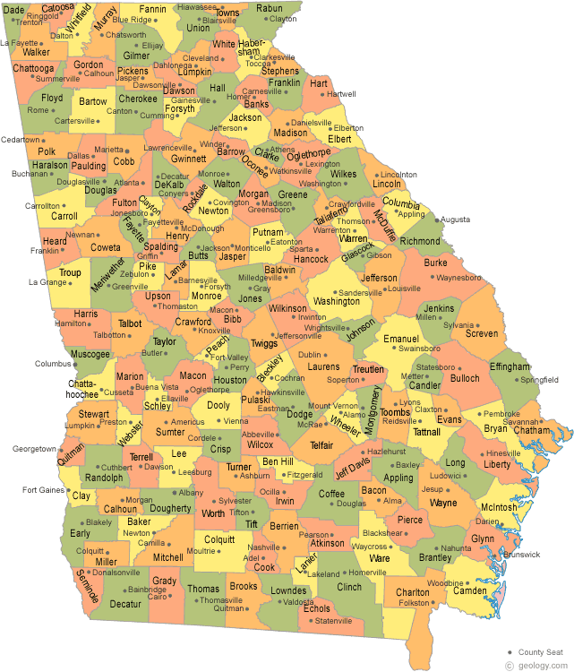

Related County Zip Codes
